**A.1 OVERVIEW**

This website is designed as an educational technology platform aimed at enhancing the learning experience through a structured and interactive digital environment. The main goal is to serve as an accessible and user-friendly learning tool for both students and teachers, especially in the context of modern, tech-driven education.

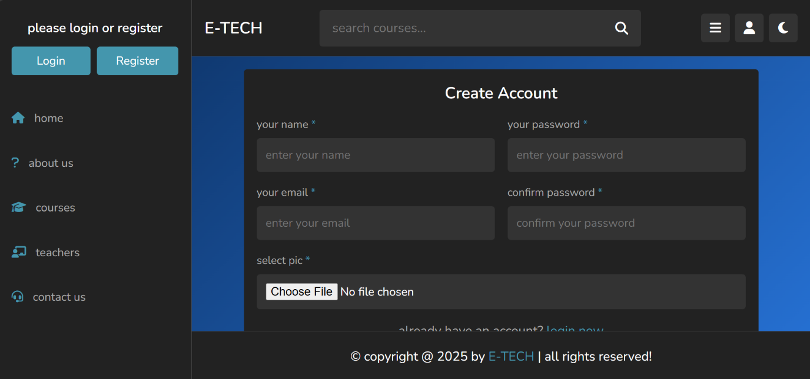

**A.1.1 (Register (Create Account))**

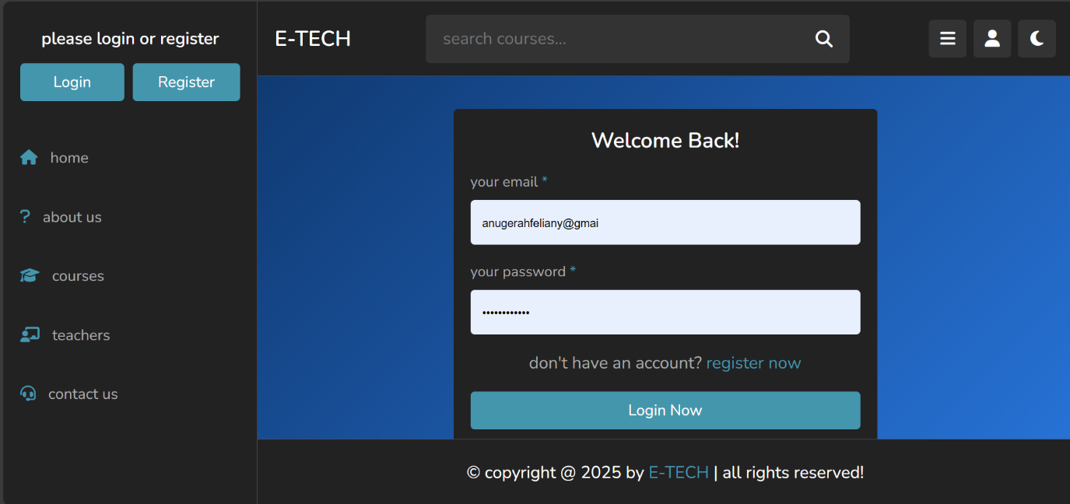

**A.1.2 (Login)**

**Login and Registration Pages**

A secure authentication system allows:

New users to register as students or teachers with tailored access.

Existing users to log in with saved credentials.

Password recovery and verification processes for account security.

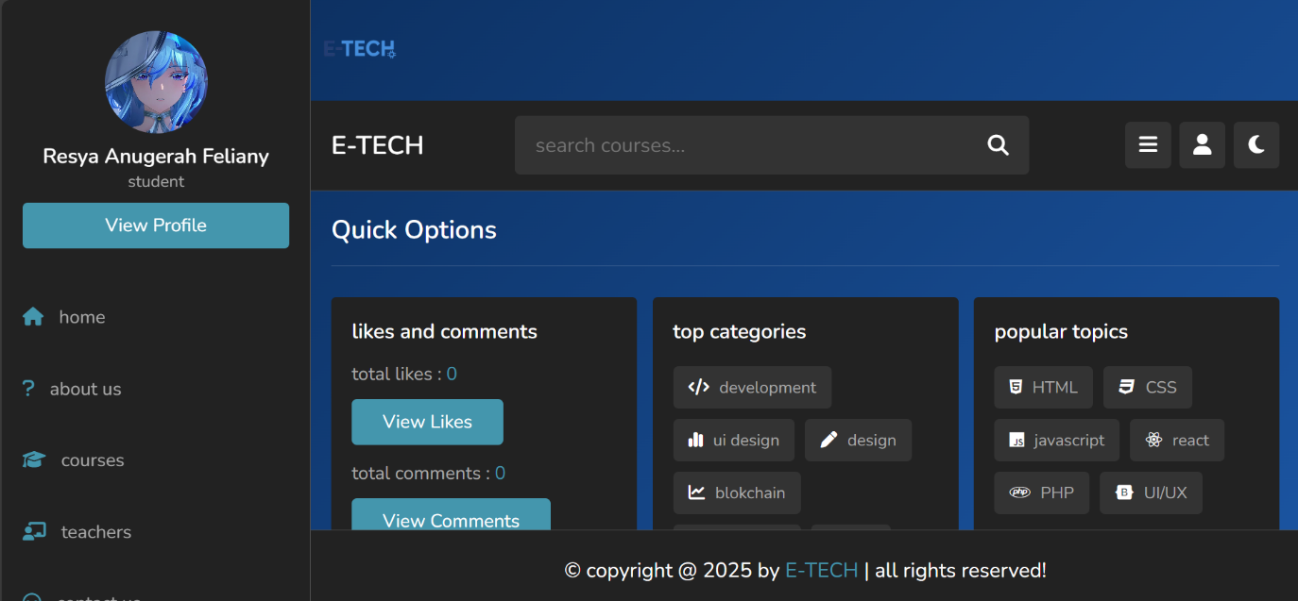

**A.1.3 (Home page(Black theme))**

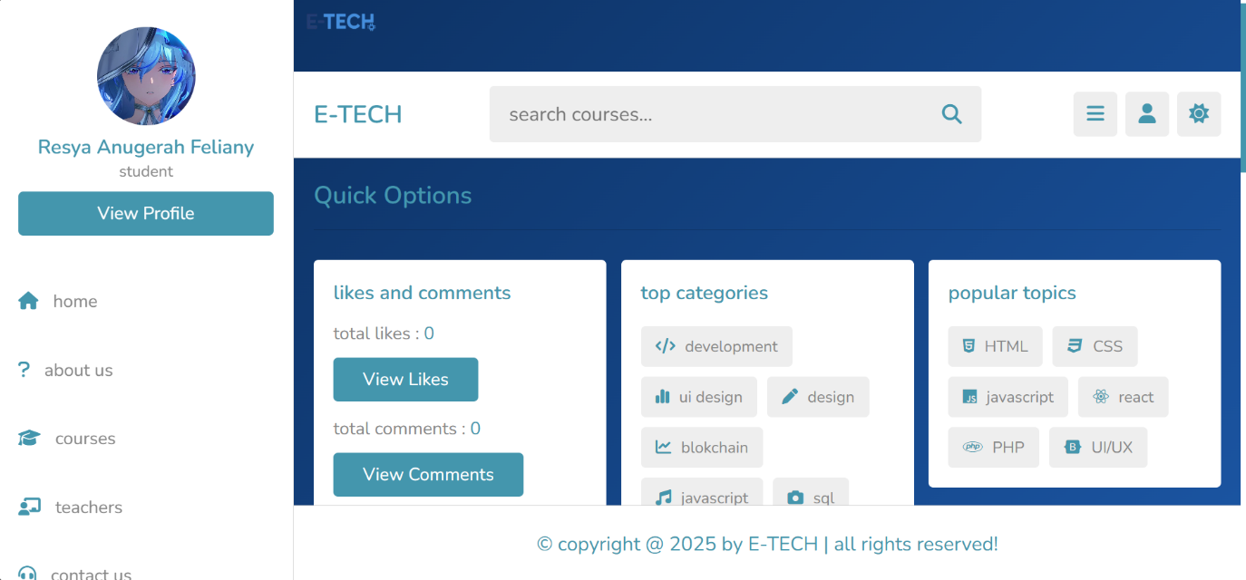

**A.1.3 (Home page(White theme))**

**Home Page**

The home page serves as the first point of interaction for users, offering a clear introduction to the platform. It includes:

A short overview of the platform’s mission and educational goals.

Highlights of the main features, such as learning materials, progress tracking, and discussion forums.

A navigation bar that links to other key sections of the site: Materials, Forum, Profile, and Settings.

A clean, responsive design that works across desktops, tablets, and smartphones.

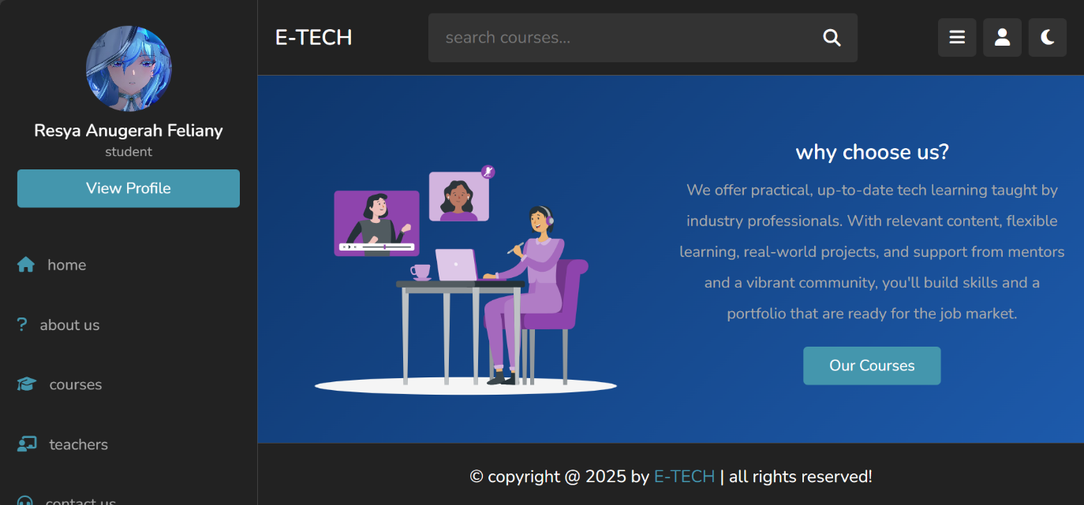

**A.1.4 ( About us)**

**About Us**

This page provides an overview of E-TECH’s background, purpose, and learning approach. It helps users understand what the platform offers, who’s behind it, and why E-TECH was created. Use this page to get to know the values, mission, and structure of our learning system.

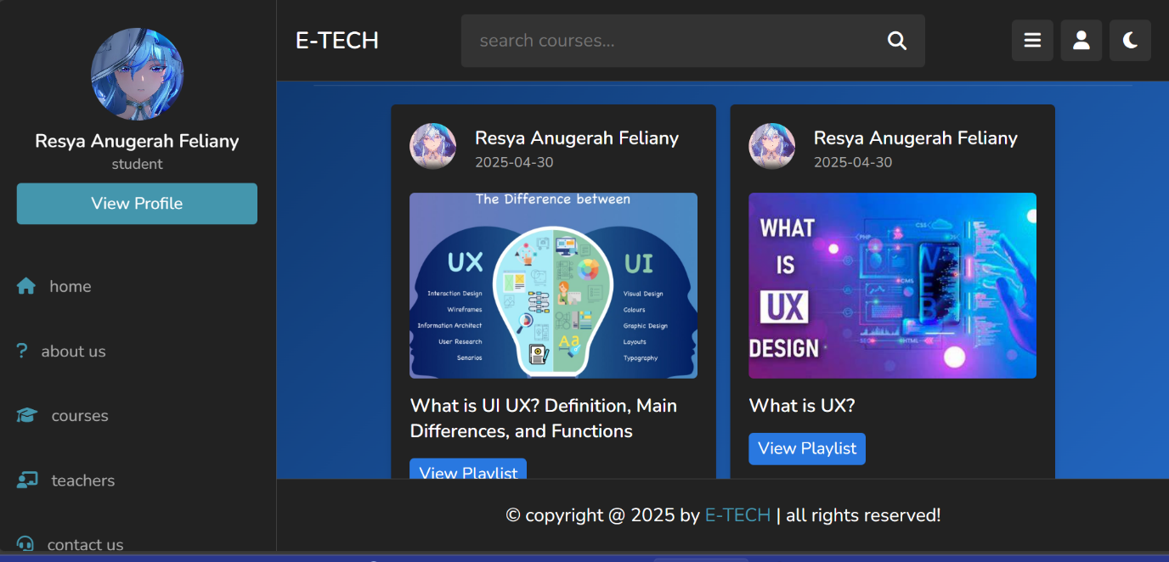

**A.1.5 (Courses)**

**Courses**

This page displays the list of available courses on E-TECH. Here, users can browse learning materials, view playlists, and explore topics based on their interests or skill level. Each course includes videos, explanations, and structured content designed to help learners grow in specific tech areas.

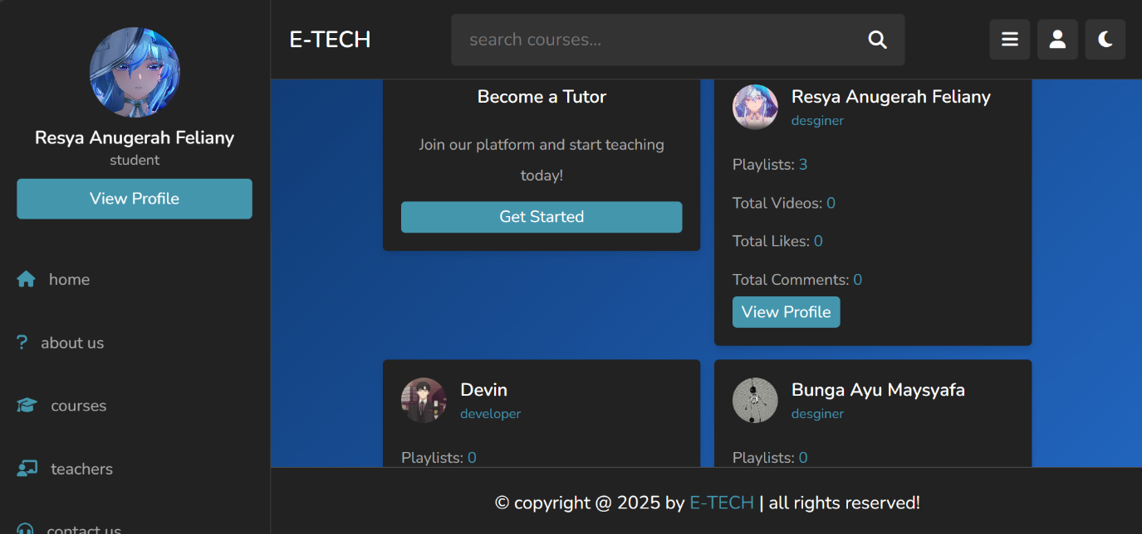

**A.1.6 (Teacher’s)**

**Teachers**

This page showcases the profiles of available tutors on E-TECH. Here, users can explore potential teachers based on their expertise and interests. Each teacher's profile includes details such as playlists created, total videos, and learner engagement metrics like likes and comments, all aimed at helping students find the right mentor to guide them in their learning journey.

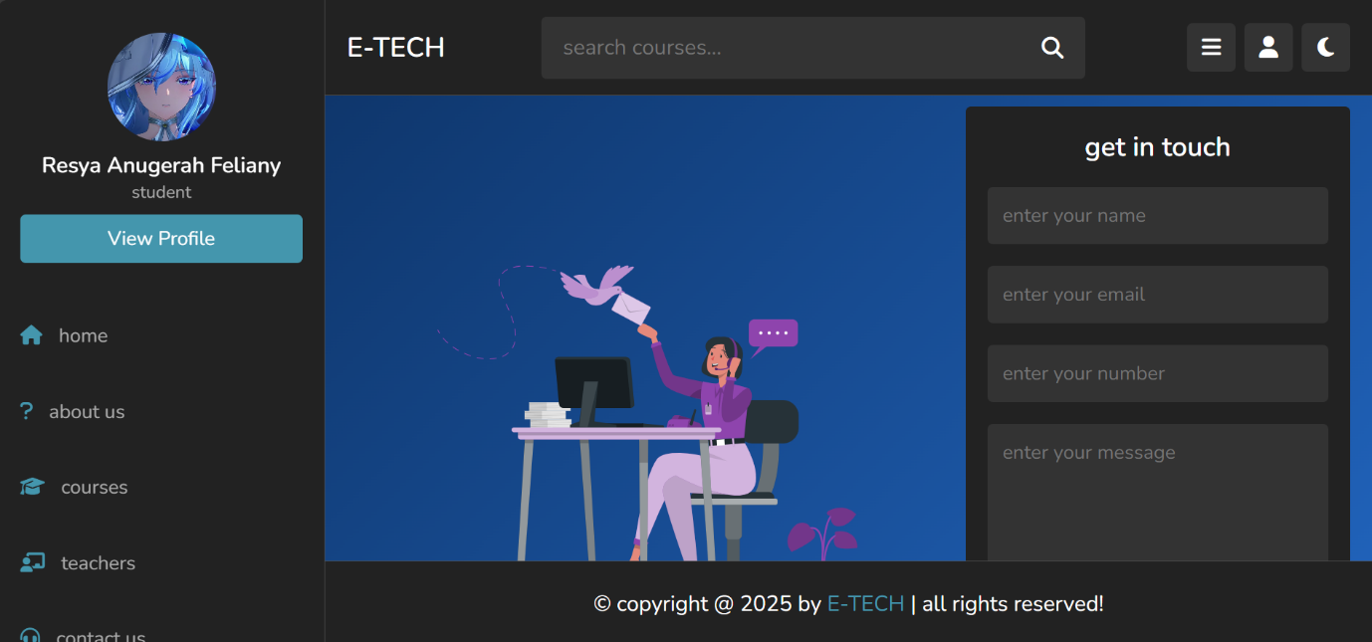

**A.1.7 (Contact Us)**

**Contact Us**

Contact Us page on E-TECH has several important elements for interacting with users. This page is designed to make it easier for users to get in touch with E-TECH regarding various questions or information needs.

**A.2.BUSSINES FUNCTION**

* **Platform Type**: E-Learning and Community Interaction
* **Target Audience**: Students, educators, and professionals in technology fields
* **Core Functions**: Course sharing, user interactions, and community building

**Key Features**

**User Profiles**

* **Profile Setup**: Username, bio, profile picture, and user type (student/teacher).
* **View Profile Option**: Allows users to view and edit their profiles.

**Course Management**

* **Course Listings**: Searchable database of courses categorized by topics (e.g., development, design, blockchain).
* **Playlist Creation**: Users can create and manage playlists of course videos.

**Engagement Tools**

* **Likes & Comments**: Users can like and comment on courses or posts.
  + Display total likes and comments on user profiles.
* **Popular Topics**: Highlight trending subjects to encourage user engagement.

**Feedback & Support**

* **Contact Us**: Allow users to send messages or inquiries directly through a contact form.

**User Interactions**

* **Follow System**: Users can follow others to receive updates on their activities or courses.
* **Messaging System**: Enable direct messaging between users.

**Marketing & Growth Strategies**

* **Social Media Integration**: Encourage users to share their achievements on other social media platforms.
* **Referral Programs**: Offer incentives for users who refer others to join the platform.
* **Content Marketing**: Create a blog focused on tech trends, tutorials, and success stories.

**Technical Infrastructure**

* **Scalable Backend**: Implement a cloud-based database to handle user data and course content.
* **Mobile Compatibility**: Ensure the platform is mobile-friendly or develop a dedicated app.
* **Security Measures**: Protect user data with encryption and privacy policies.

**A.3.DATA REQUIREMENTS**

**1. User Profile Data**

* **User Information**
  + Name
  + Email
  + Profile Picture
  + User Type (e.g., student, teacher)
* **User Activity**
  + Total Likes
  + Total Comments
  + Total Videos
  + Playlists

**2. Course Data**

* **General Course Information**
  + Course Title
  + Course Description
  + Enrolled Students
  + Course Category (e.g., development, design)
* **Course Popularity**
  + Total Likes
  + Total Comments
  + Total Views

**3. Categories and Topics**

* **Top Categories**
  + Category Name (e.g., development, UI design, blockchain)
  + Number of Courses in Category
* **Popular Topics**
  + Topic Name (e.g., HTML, CSS, JavaScript, React)

**4. Engagement Data**

* **Likes and Comments**
  + Total Likes per Post
  + Total Comments per Post
  + View Counts for Likes and Comments

**5. Communication Data**

* **Feedback/Contact Form Data**
  + User Name
  + User Email
  + User Phone Number
  + Message Content

**6. Authentication Data**

* **Login Credentials**
  + User Email/Username
  + Password (hashed)
* **Registration Data**
  + Required Fields (Name, Email, Password, Profile Picture)
  + Confirm Password Field

**7. Metadata**

* **Page Metadata**
  + Copyright Information
  + Year of Website Creation (e.g., 2025)

**A.4 BUSSINES RULES**

1. **User Registration and Accounts**
   * Users must provide their name, email, password, and profile picture to create an account.
   * Email verification is required upon registration.
2. **User Roles**
   * Users can be categorized as either students or tutors.
   * Tutors must undergo a verification process before being able to create or manage courses.
3. **Course Creation and Management**
   * Only verified tutors can create and upload courses.
   * Courses must have a title, description, category, and educational materials.
4. **Course Enrollment**
   * Students can enroll in courses by clicking the 'Enroll' button.
   * Payment is required for premium courses before access is granted.
5. **Engagement Metrics**
   * Users can like and comment on courses.
   * Total likes and comments are displayed on course pages for engagement tracking.
6. **Support and Communication**
   * Users can contact support through a designated contact form.
   * Response to inquiries must be provided within 48 hours.
7. **Course Categories and Tags**
   * Courses should be categorized under at least one of the predefined categories, such as Development, Design, and Blockchain.
   * Tags can be used for aiding search and course discovery.
8. **Content Guidelines**
   * All course materials must adhere to copyright laws and should not contain any plagiarized content.
   * Inappropriate content is strictly forbidden and may lead to account suspension.
9. **User Profiles**
   * Users can view and edit their profile information including bio and course statistics.
   * Student profiles display engaged courses, completed learning paths, and total likes/comments.
10. **Feedback and Review System**
    * Students can leave feedback and reviews for courses they have completed.
    * Feedback will be used to evaluate course quality and tutor performance.
11. **Security Parameters**
    * User passwords must meet complexity requirements (at least 8 characters, including letters and numbers).
12. **Data Privacy**
    * User data must be handled in compliance with data protection regulations.
    * Users have the right to request deletion of their accounts and associated data.